|  |
| --- |
| **Blackpool and The Fylde College** |
| **Midgar Application Design – Team Development – Task 1** |
| **Rich Internet Applications** |
| BSc. Interactive Media Development |
| Tutor: Christopher Willitts |
|  |
| **Robert Sims** |
| ***4/23/2017*** |

|  |
| --- |
|  |

Contents

Change Log 2

Introduction 3

Functionality 4

Designs 6

References 7

Bibliography 8

Appendicies 9

Appendix a 9

# Change Log

|  |  |  |  |
| --- | --- | --- | --- |
| **Version** | **Author** | **Date** | **Description** |
| 0.1 | R Sims | 24/03/2017 | Initial draft for review |
|  |  |  |  |
|  |  |  |  |
|  |  |  |  |
|  |  |  |  |
|  |  |  |  |

# Introduction

This document serves to detail the initial design considerations and functionality of an RSS aggregation application.

# Functionality

The core functionality of the application is as follows:-

|  |  |  |  |
| --- | --- | --- | --- |
| **Requirement #** | **Element** | **Purpose** | **Considerations** |
| C1 | Login | Allow the user to login to the application so that user specific content may be displayed | Password storage should be encrypted  Allow user to reset password themselves. |
| C2 | RSS feeds | Display a list of available RSS feeds | Allow the user to subscribe and unsubscribe to feeds so that personalised feeds may be shown |
| C3 | Contact form | Allow the user to contact a support team in case of issues |  |
| C4 | Admin panel | Allow admins to add new RSS feeds, categorise them, edit them and delete them |  |
| C5 | Offline mode | Allow content to be displayed offline | Consider how the user might be notified that there is no internet connection |
|  |  |  |  |

Table 1 Core functionality

Once the core functionality is completed and validated, the following extension functions are desired:-

|  |  |  |  |
| --- | --- | --- | --- |
| **Requirement #** | **Element** | **Purpose** | **Considerations** |
| E1 | Trending topics/feeds | Have the app display most subscribed/most read feeds etc |  |
| E2 | User suggestion of feeds | Allow users to suggest new feeds to be added to the application | Suggestions should be moderated by an admin team to ensure appropriate content and valid feeds |
| E3 | Localisation | Allow feeds/articles to be displayed in the user preferred language |  |
| E4 | Rating of feeds | Allow users to rate feeds | Possible a star system – 1 bad 5 excellent or similar. |
| E4 | User profiles | Allow user to tailor their user profiles | Avatar, real name etc. |
| E5 | Filtering | Allow feeds to be filtered for display | Filter by author, category etc |
| E6 | Subscribe all | After a filter has been applied, allow user to subscribe to all displayed feeds |  |
| E7 | Deploy as device app | Allow the application to be deployed to devices | Consider Android, iOS and Windows mobile. |
|  |  |  |  |

# Designs

A responsive template called Editorial (Editorial by Pixelarity, 2017) by Pixelarity has been chosen to provide the initial platform for the development of the application. In tandem with this template, a UI Style Guide (see appendix A) has been created that sets out the main UI (User Interface) elements that should persist throughout all areas of the application. In general, additional elements added to the site will attempt to adhere to the layout a colour scheme displayed within the template and UI Style Guide, as seen below with the mock-up of the admin panel functionality:-

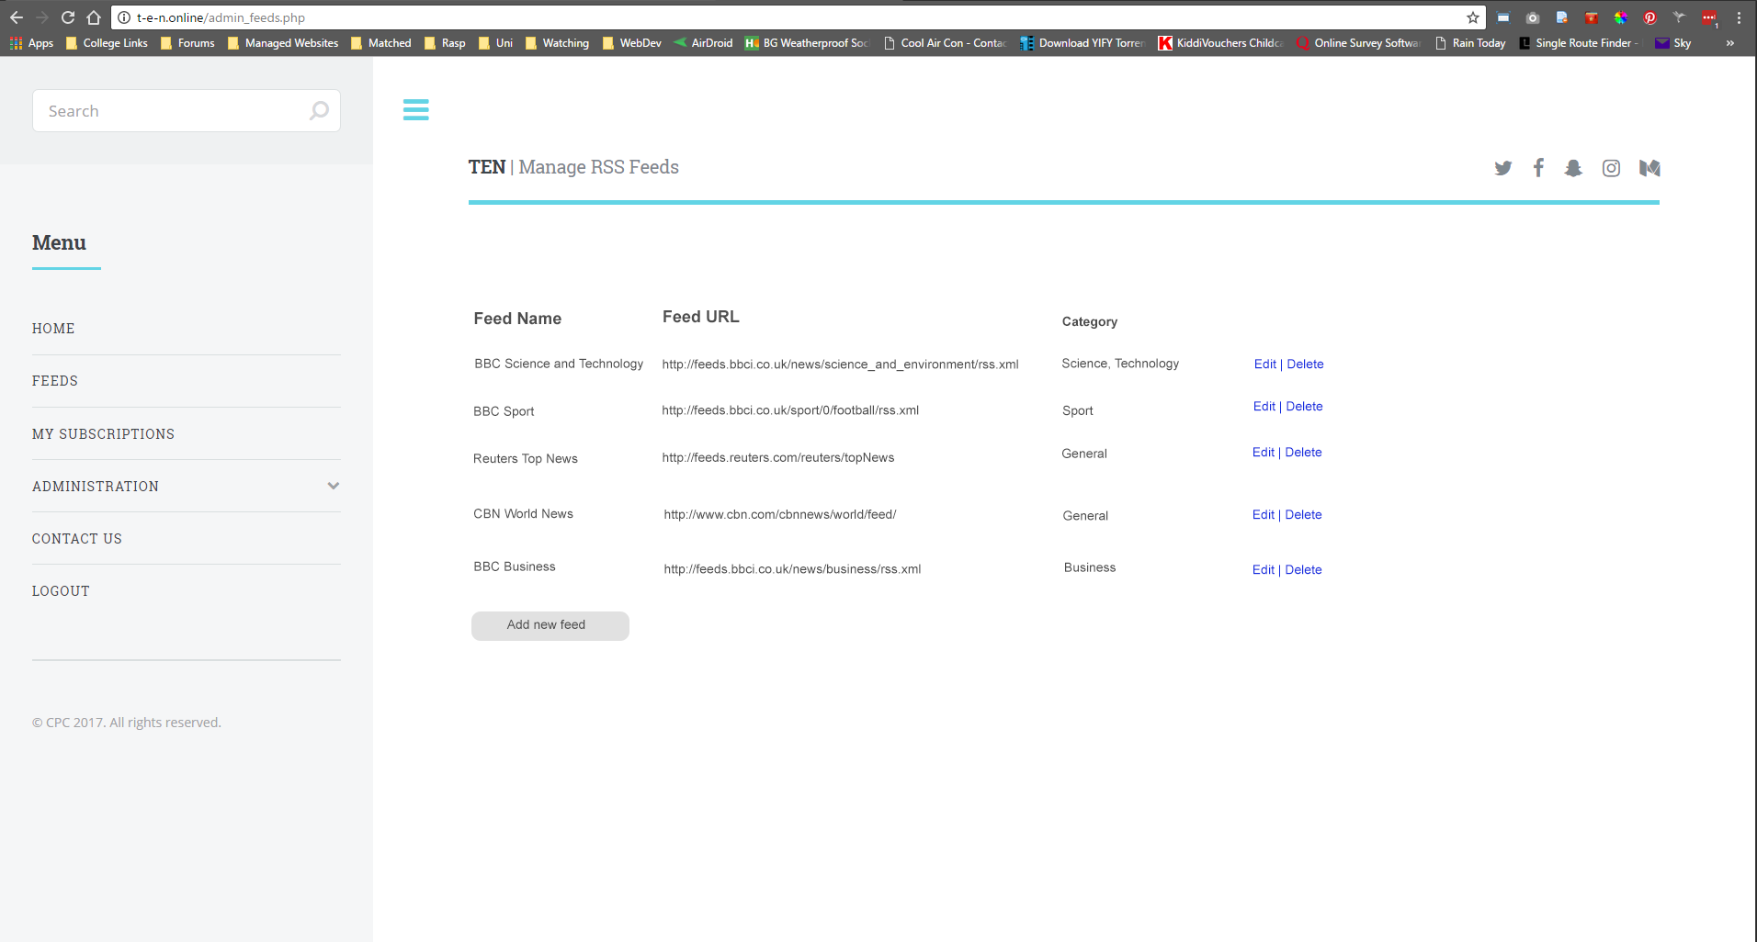

Figure 1 Mock-up of admin panel functionality displaying layout and colour scheme.

Wireframes and further mock-ups have not been produced for the site as it is intended that development will take the form of a rapid prototype. Due to the inexperience of the development team and their relative strengths and weaknesses being unknown, it was felt that overly descriptive wireframes and mock-ups would introduce undue restrictions on the development process. Having a more fluid and flexible design ethos allows the developers to explore and experiment with possible solutions to design challenges and perhaps encourage them to attempt development tasks outside of their areas of expertise.

# References

Editorial by Pixelarity (2017) *https://pixelarity.com*. Available at: https://pixelarity.com/editorial (Accessed: 24 March 2017).

# Bibliography

# Appendicies

## Appendix a

